How do I log into Clever as a student if the Clever badge is not working?

1. To log into the Clever Portal, go to our School 25 homepage or <https://clever.com/in/yonkers/student/portal> **.**
2. Log in using your district username and password. Your child’s username is their **id number followed by @yonkerspublicschools.org** Their password is

**\*\*\*\*For example: Username 904567@yonkerspublicschools.org**

Password **date of birth ex. 01012020**

From your Clever Portal, click on the application icon you’d like to use:

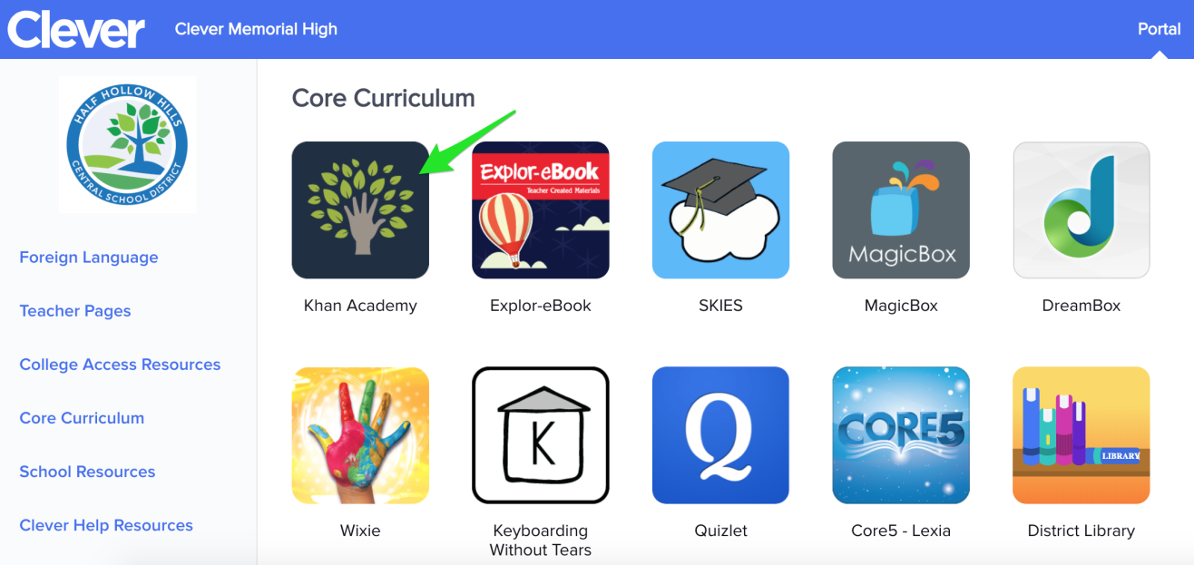

If you need any help or their id number please contact me!

On the class Dojo or at aharrison@yonkerspublicschools.org